Use Cases of AI-Powered X-Ray Detection with
Explainable AI

Use Case 1: Disease Detection from X-Ray

- Actor: Doctor, Radiologist, or Technician
- Description: The user uploads a chest X-ray image (JPG, PNG, or DICOM) to the web platform for automated diagnosis.
- System Response: The AI model (e.g., CNN, ResNet, DenseNet) analyzes the image and predicts whether pneumonia or tuberculosis is present, along with a confidence score.
- Outcome: The user receives a diagnostic report indicating disease type, severity probability, and visual heatmap highlighting the affected lung regions.

Use Case 2: Explainable AI Visualization

- Actor: Doctor or Radiologist
- Description: After receiving a diagnosis, the user wants to understand how the AI reached its conclusion.
- System Response: The system generates explainability visualizations using Grad-CAM or LIME, marking the critical image regions influencing the decision.
- Outcome: The doctor views highlighted areas on the X-ray, improving trust, interpretability, and diagnostic confidence.

Use Case 3: Quick Triage and Emergency Flagging

- Actor: Hospital Staff or Emergency Doctor
- Description: User uploads multiple X-rays for patients in the emergency ward.
- System Response: The system automatically identifies high-risk cases (e.g., severe pneumonia or TB) and flags them as “urgent” for immediate review.
- Outcome: Critical patients are prioritized for treatment, reducing diagnostic delay and improving patient outcomes.

Use Case 4: Rural and Remote Health Screening

- Actor: Rural Clinician, NGO Worker, or Mobile Health Unit Staff
- Description: The user uploads X-rays collected during rural screening or medical camps.
- System Response: The AI system provides instant, explainable diagnoses without the need for a specialist on-site.
- Outcome: Rural health workers can identify probable TB or pneumonia cases early, enabling timely referral or treatment.

Use Case 5: Patient Record and Report Management

- Actor: Doctor, Technician, or Hospital Administrator
- Description: The user adds or retrieves patient information, diagnostic history, and X-ray reports through the dashboard.
- System Response: The system stores patient data securely, allowing access to past X-rays, AI predictions, and Grad-CAM images.
- Outcome: Clinicians can monitor disease progression and maintain organized medical records for follow-up care.

Use Case 6: Model Training and Performance Monitoring

- Actor: Data Scientist or ML Engineer
- Description: The user uploads new labeled X-ray datasets to train or fine-tune the AI model.
- System Response: The system retrains the deep learning model, evaluates accuracy, and updates performance metrics (accuracy, F1-score, ROC-AUC).
- Outcome: The AI model improves over time, adapting to local data and increasing diagnostic precision.

Use Case 7: Medical Student Learning and Training

- Actor: Medical Student or Trainee
- Description: The user views anonymized X-rays and corresponding AI explanations to learn disease patterns.
- System Response: The system presents example cases with highlighted regions showing how the AI identifies pneumonia or TB indicators.
- Outcome: Students gain practical understanding of chest disease detection and AI-based image interpretation.

Use Case 8: AI Chatbot Medical Assistant

- Actor: Any Platform User (Doctor, Technician, Student)
- Description: The user queries the AI chatbot for help—such as how to upload X-rays, interpret Grad-CAM results, or understand model accuracy.
- System Response: The chatbot provides contextual, conversational guidance using stored documentation and model insights.
- Outcome: Users receive instant support and explanations without needing external help or documentation lookup.

UseCase Diagram:

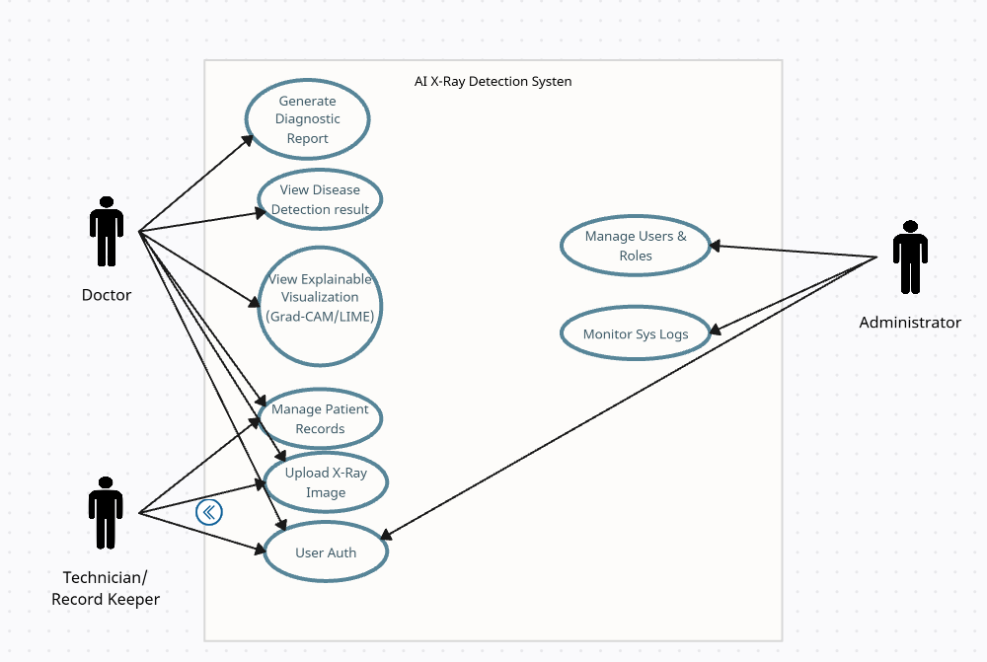

ERD Diagram:

